PROJECT SYNOPSIS
On
MediGenie: A Multi-Agent, Multi-Model AI Framework for Explainable Clinical Decision Support
to be submitted by
Adarsh Raj
Roll No.- 2400300109001
Piyush Gupta
Roll No.- 2400300109003
for the award of the degree of
BACHELOR OF TECHNOLOGY
in
Computer Science and Engineering

INDERPRASTHA ENGINEERING COLLEGE, GHAZIABAD
SESSION 2026–27
TABLE OF CONTENTS
1. Abstract of the Project 3
2. Novelty of Project 3
3. Introduction 4
4. Objectives of Project 4
5. Proposed Methodology 5
6. Brief Literature Review 7
7. Gap Analysis 9
8. Scope of Project with Hardware/Software Requirements 9
9. Main Functionalities of Project 10
10. Timeline for the Project 11
11. References (IEEE format) 12

1. Abstract of the Project
Doctors today are expected to go through a lot of information in very little time. A single patient visit can involve symptoms, past medical history, several lab reports and sometimes a list of medications, and all of this has to be reviewed within a short consultation window. Most AI tools built for healthcare only help with one part of this process, usually through a single machine learning model solving one narrow problem, such as predicting a disease risk score or summarising a report. This project, MediGenie, takes a different approach. Instead of one model handling everything, the system is built around several AI agents working together, each responsible for a specific task such as reading lab reports, checking drug safety, retrieving relevant medical guidelines, or predicting disease risk, all coordinated by a central Supervisor Agent. Every recommendation the system produces will be backed by either retrieved medical evidence or a confidence score, so that a doctor can actually see why a suggestion was made rather than simply trusting a number. The system is not meant to replace a doctor's judgement. It is meant to reduce the manual work involved in gathering information, and to make the reasoning behind each AI suggestion visible instead of hidden.

2. Novelty of Project
What makes MediGenie different is not any single technique on its own, since multi-agent systems, retrieval-augmented generation and explainable AI have each been studied before. The novelty here is in combining them for one specific purpose: clinical decision support. Most published work picks one of these ideas and applies it in isolation, for instance a paper that studies retrieval-augmented generation on its own, or a paper that studies multi-agent conversation between language models without applying it to a real clinical workflow [11]. MediGenie treats multi-agent collaboration, model specialisation, evidence retrieval and explainability as requirements that all have to be satisfied together, rather than as separate research questions to be solved individually. A second point of novelty is architectural rather than purely algorithmic: every recommendation generated by the system is required to carry either a retrieved evidence source or a numerical confidence score, so explainability is built into the design from the start instead of being added afterwards as an extra feature.

3. Introduction
Artificial intelligence has found its way into almost every part of healthcare over the last decade, from reading X-rays to managing hospital scheduling [2]. One area that has received particular attention is the Clinical Decision Support System, or CDSS, which is essentially software designed to help a doctor make better decisions by combining patient data with medical knowledge [1]. The idea sounds simple, but building a CDSS that doctors actually trust and use in practice has turned out to be harder than it first appears.
Part of the difficulty is that most CDSS tools available today are narrow in scope. A system might be very good at predicting one specific disease risk, or very good at summarising a lab report, but it rarely does both, and it almost never explains its reasoning in a way a clinician can quickly verify. When a doctor is handed a risk score with no explanation of how it was calculated, there is little reason to trust it over their own judgement, and adoption of the tool suffers as a result [12].
This project is an attempt to build something closer to how a real clinical team actually works. Rather than one model doing everything, MediGenie splits the decision-support process into separate tasks, each handled by an agent that specialises in that particular task. A Patient Intake Agent gathers symptoms and history, a Report Analysis Agent reads uploaded lab reports, a Risk Assessment Agent estimates disease risk, a Knowledge Retrieval Agent looks up relevant medical guidelines, and a Drug Safety Agent checks for interactions. A Supervisor Agent ties all of these outputs together into one final report.
The people who would actually use this system are doctors and clinical staff first, since the main goal is to save them time on the repetitive parts of information-gathering. Medical students are a secondary audience, since seeing the evidence behind each recommendation is a reasonable way to learn how structured clinical reasoning works in practice. At no point does the system attempt to make a final diagnosis or take over the responsibility that sits with the physician. It is built to support that decision, not to make it on anyone's behalf.

4. Objectives of Project
The objectives below are written so that each one can be checked against a concrete number or outcome once the project is finished, rather than left open to interpretation:
- Build a working multi-agent pipeline with at least eight agents (patient intake, report analysis, risk assessment, knowledge retrieval, drug safety, recommendation and report generation, coordinated by a Supervisor Agent).
- Train a disease-risk prediction model that reaches at least 85% classification accuracy on a benchmark dataset such as the UCI Heart Disease dataset.
- Build a retrieval pipeline that achieves a Precision@5 of at least 0.75 when tested against a set of sample patient queries.
- Ensure that every recommendation shown in a generated report is linked to either a retrieved source or a confidence score, with no unsupported claims found during manual review of test cases.
- Benchmark the completed multi-agent system against a single-model baseline performing the same task, and report the difference in performance.
- Have a working end-to-end demonstration, from patient data entry to a downloadable PDF report, ready before the end of the one-year timeline.

5. Proposed Methodology
Building MediGenie is planned as a sequence of connected stages rather than one large development push, and Fig. 1 shows how these stages fit together once the system is running.
The starting point is data. A patient's symptoms, history and any uploaded lab reports go into the system through a simple intake form. If a report happens to be a scanned image rather than typed text, it first passes through Optical Character Recognition so the content can be read at all; the extracted text is then handed to a biomedical language model, either BioBERT [5] or ClinicalBERT [6], since general-purpose language models are not particularly reliable at parsing terms like “HbA1c” or “creatinine clearance” correctly. Both of these biomedical models are themselves built on the Transformer architecture [4] that BERT [3] popularised for language understanding.
For the actual disease-risk calculation, the plan is to use XGBoost [8], a tree-based machine learning algorithm rather than a deep neural network. The reasoning here is fairly practical: tree-based models tend to perform well on structured tabular data such as lab values and vitals, and they are considerably easier to interpret than a black-box neural network, which matters a great deal when a clinician needs to understand why a particular risk score came out the way it did. Training will start on the UCI Heart Disease dataset [13] and the Diabetes 130-US Hospitals dataset [14], both of which are publicly available and commonly used for this kind of experimentation. Access to MIMIC-IV [15] will be requested separately for later validation, since it requires a formal credentialing process that is unlikely to be approved quickly.
Alongside risk prediction, the system also needs to be able to pull up relevant medical guidelines rather than relying purely on whatever a language model happens to remember from its training data. This is handled through a Retrieval-Augmented Generation setup [10]: guideline documents are converted into embeddings using Sentence-BERT [7], stored in a FAISS index [9], and searched whenever a patient case needs supporting evidence. A separate, simpler agent checks the patient's medication list against a reference table of known drug interactions and allergy classes, which does not need a machine learning model at all, just a reliable lookup.
Once all of the individual agents have produced their outputs, a Supervisor Agent, built using the LangGraph framework, brings everything together into a single report, as summarised in Fig. 2. A large language model handles the actual writing of this report, but it is restricted to summarising what the other agents have already found; it is not allowed to introduce new medical claims of its own. The finished report can also be exported in HL7 FHIR format [16], so that it could, in principle, be shared with other hospital systems at a later stage.
The whole pipeline sits behind a FastAPI backend, with a browser-based frontend where a clinician can review, edit or reject each recommendation before it is finalised.
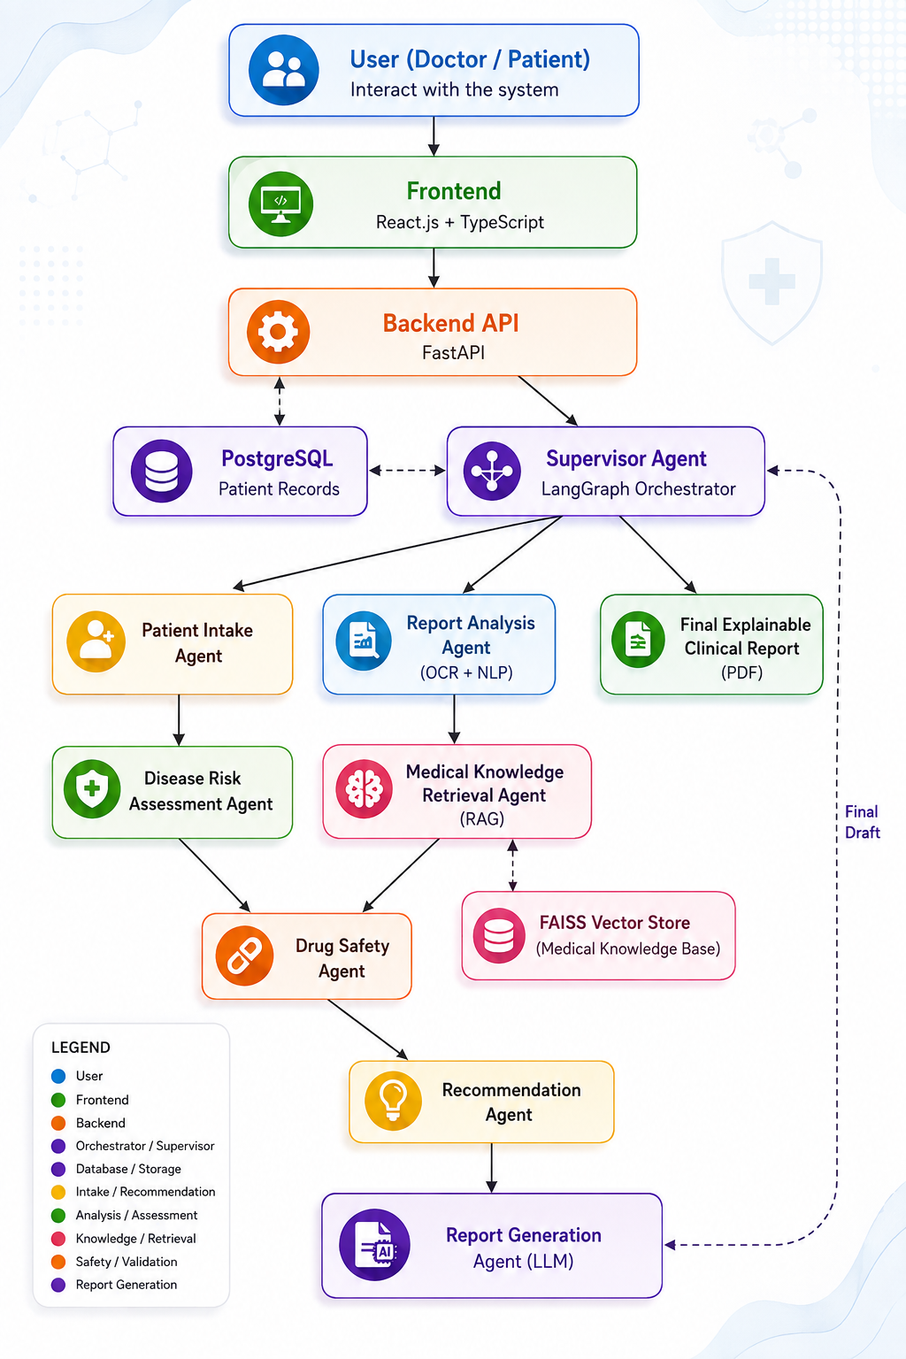
Fig. 1. Overall system architecture of MediGenie, showing the flow from user input through the Supervisor Agent and specialised agents to the final report.
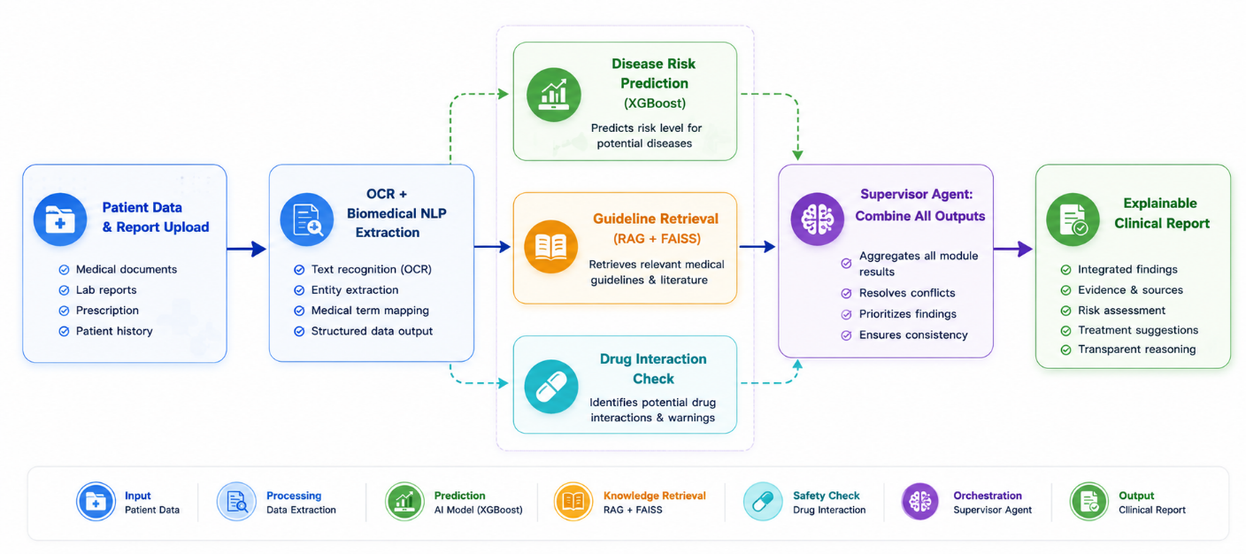
Fig. 2. Step-by-step processing flow from patient data input to the final explainable clinical report.

6. Brief Literature Review
A good starting point is Sutton et al. [1], who reviewed a large number of deployed clinical decision support systems and found that while these systems can genuinely improve outcomes, badly designed ones generate so many low-value alerts that clinicians eventually start ignoring them altogether. Their review is useful for understanding why trust matters so much, but it does not really propose an architecture, it mostly diagnoses the problem. Topol [2] covers similar ground from a broader perspective on AI in medicine, again without getting into how such a system might actually be built.
On the language side, most of the recent progress traces back to the Transformer architecture introduced by Vaswani et al. [4], which BERT [3] later built on to create a model that understands context from both directions of a sentence. Neither of these was designed with medical text in mind, though, which is why domain-specific variants exist. Lee et al. [5] pre-trained BioBERT specifically on biomedical literature, and Alsentzer et al. [6] took this further by fine-tuning on actual clinical notes to produce ClinicalBERT. Both papers show a clear improvement over general-purpose BERT on medical NLP tasks, but neither one attempts to connect this improved text understanding to a downstream decision-support pipeline, which is really the gap this project sits in.
For the prediction side of things, Chen and Guestrin's XGBoost paper [8] is fairly old at this point but is still the standard reference for gradient-boosted trees, and it remains a strong choice for structured clinical data even though the paper itself has nothing to do with healthcare specifically.
Retrieval-Augmented Generation, introduced by Lewis et al. [10], is probably the single most relevant piece of prior work here, since it directly demonstrates that grounding a language model's output in retrieved text reduces the kind of confident-but-wrong answers that plain language models are known for. Making retrieval fast at scale depends on the sentence-embedding work of Reimers and Gurevych [7] and the similarity-search techniques described by Johnson et al. [9]. Separately, Wu et al. [11] show that having multiple LLM-based agents talk to each other can outperform a single agent on complex tasks, though their AutoGen framework is tested on general problem-solving rather than anything medical.
Finally, Tjoa and Guan [12] survey explainability methods specifically for medical AI and make a point that comes up again and again in this literature: a lack of interpretable output is one of the biggest reasons clinicians do not trust AI tools, regardless of how accurate the underlying model actually is.
Taken together, these works cover the individual pieces well, language understanding, prediction, retrieval, multi-agent coordination and explainability, but none of them combine all five into a single clinical system, which is exactly the space this project is trying to occupy.

7. Gap Analysis
Looking at the literature as a whole, a fairly clear picture emerges. Individually, biomedical language models, gradient-boosted risk prediction, retrieval-augmented generation and multi-agent LLM frameworks are all reasonably mature areas of research on their own. What is missing is a system that puts these pieces together specifically for clinical decision support, with explainability treated as a core requirement rather than something bolted on afterwards. CDSS reviews such as [1] identify trust and explainability as the main reasons clinicians resist adopting AI tools, but the systems being reviewed rarely address this at the architecture level. Retrieval-augmented generation [10] and multi-agent coordination [11] have each been shown to work well within their own domains, but not combined, and not applied to healthcare specifically. MediGenie is proposed to close exactly this gap, by building a system where multi-agent collaboration, model specialisation and evidence-grounded explainability are all part of the same design from the outset, and then testing whether this actually performs better than a conventional single-model approach on the same task.

8. Scope of Project with Hardware/Software Requirements
To keep this project realistic within a one-year timeline, its scope is deliberately narrow. MediGenie will handle general risk assessment based on structured lab and demographic data, and it will retrieve supporting evidence from a curated set of medical guidelines rather than the entire body of medical literature. Patient intake, report analysis, risk scoring, guideline retrieval, drug interaction checks and report generation are all within scope. Autonomous diagnosis, prescribing medication, analysing medical images such as X-rays, and live integration with an actual hospital's records system are explicitly out of scope, partly because these would require regulatory approval and clinical trials well beyond what a student project can reasonably attempt in a year. Testing will be done on public benchmark datasets rather than real patient records, both for practical reasons and because using real patient data would require ethics approval and privacy safeguards that are not feasible to arrange within this timeline. Table I lists the hardware and software needed to build and test the prototype.
Table I. Hardware and Software Requirements
Category | Requirement
Development hardware | Laptop/workstation, minimum 16 GB RAM; GPU with 6 GB+ VRAM recommended for model fine-tuning
Deployment hardware (prototype) | Cloud VM instance (e.g. 4 vCPU, 16 GB RAM) or equivalent
Operating system | Windows 10/11 or Ubuntu 20.04 LTS or later
Programming languages | Python 3.10+, TypeScript
Backend / Frontend framework | FastAPI; React.js
Database | PostgreSQL
ML / NLP libraries | scikit-learn, XGBoost, Hugging Face Transformers, Sentence-Transformers
Vector search | FAISS
Agent orchestration | LangGraph / LangChain
Containerisation | Docker

9. Main Functionalities of Project
The system is organised into five main modules, each doing one clearly defined job.
Patient Intake and Report Analysis Module
This is the entry point of the system: it takes in the patient's symptoms and history through a form, and if a lab report is uploaded, it runs OCR followed by a biomedical language model to turn the raw report into something structured that the rest of the system can actually use.
Disease Risk Assessment Module
This module takes the structured data and runs it through the trained XGBoost model to produce a risk score, a severity estimate and a confidence value, the last of which matters because a prediction the model is unsure about should not be treated the same way as one it is fairly confident in.
Medical Knowledge Retrieval Module
This module searches the guideline knowledge base for anything relevant to the patient's specific situation, so that whatever gets recommended later can be traced back to an actual source rather than the language model's own memory.

Drug Safety Module
This module checks the patient's current medications and allergy history against a reference table, flagging anything that looks like a potential interaction or contraindication before it reaches the final report.
Recommendation and Report Generation Module
Coordinated by the Supervisor Agent, this module pulls together everything the other modules found and produces one explainable report, with every suggestion tied to either retrieved evidence or a confidence score, exportable as a PDF and, if needed, as an HL7 FHIR record.

10. Timeline for the Project
The project is planned across the full one-year duration, broken into nine milestones rather than a small number of broad phases, since a handful of vague phases would not give a realistic sense of when each part of the system is actually expected to work. Table II lists each milestone along with its dependency on earlier work, and Fig. 3 presents the same plan visually.
Table II. Project Timeline
Milestone | Duration | Deliverable | Dependency
M1: Requirement analysis & literature review | Months 1–2 | Finalised requirements document; literature review | None
M2: Dataset acquisition & preprocessing | Months 2–3 | Cleaned benchmark datasets; MIMIC-IV access request submitted | M1
M3: Disease-risk model development | Months 3–4 | Trained and benchmarked XGBoost risk model | M2
M4: RAG pipeline & knowledge base construction | Months 4–6 | Populated vector knowledge base; functional retrieval pipeline | M2
M5: Agent development (Intake, Report Analysis, Drug Safety) | Months 5–7 | Individually tested agent modules | M3, M4
M6: Supervisor Agent orchestration & backend integration | Months 7–9 | Integrated FastAPI backend with working end-to-end pipeline | M5
M7: Frontend development & report generation | Months 8–10 | Functional web interface; PDF report generation | M6
M8: Testing, evaluation & comparative benchmarking | Months 10–11 | Evaluation report comparing system to single-model baseline | M7
M9: Documentation & final presentation | Months 11–12 | Final project report, presentation, demonstration | M8
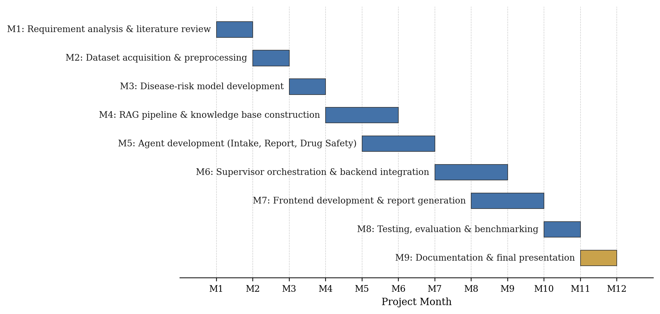
Fig. 3. Gantt-style view of the nine project milestones across the twelve-month timeline.

11. References (IEEE format)
[1] R. T. Sutton, D. Pincock, D. C. Baumgart, D. C. Sadowski, R. N. Fedorak, and K. I. Kroeker, "An overview of clinical decision support systems: benefits, risks, and strategies for success," npj Digital Medicine, vol. 3, no. 1, p. 17, 2020.
[2] E. J. Topol, Deep Medicine: How Artificial Intelligence Can Make Healthcare Human Again. New York, NY, USA: Basic Books, 2019.
[3] J. Devlin, M.-W. Chang, K. Lee, and K. Toutanova, "BERT: Pre-training of deep bidirectional transformers for language understanding," in Proc. 2019 Conf. North American Chapter Assoc. Comput. Linguistics (NAACL-HLT), Minneapolis, MN, USA, 2019, pp. 4171–4186.
[4] A. Vaswani et al., "Attention is all you need," in Proc. 31st Int. Conf. Neural Information Processing Systems (NeurIPS), Long Beach, CA, USA, 2017, pp. 5998–6008.
[5] J. Lee, W. Yoon, S. Kim, D. Kim, S. Kim, C. H. So, and J. Kang, "BioBERT: a pre-trained biomedical language representation model for biomedical text mining," Bioinformatics, vol. 36, no. 4, pp. 1234–1240, Feb. 2020.
[6] E. Alsentzer, J. Murphy, W. Boag, W.-H. Weng, D. Jindi, T. Naumann, and M. McDermott, "Publicly available clinical BERT embeddings," in Proc. 2nd Clinical Natural Language Processing Workshop, Minneapolis, MN, USA, 2019, pp. 72–78.
[7] N. Reimers and I. Gurevych, "Sentence-BERT: Sentence embeddings using Siamese BERT-networks," in Proc. 2019 Conf. Empirical Methods in Natural Language Processing and 9th Int. Joint Conf. Natural Language Processing (EMNLP-IJCNLP), Hong Kong, China, 2019, pp. 3982–3992.
[8] T. Chen and C. Guestrin, "XGBoost: A scalable tree boosting system," in Proc. 22nd ACM SIGKDD Int. Conf. Knowledge Discovery and Data Mining, San Francisco, CA, USA, 2016, pp. 785–794.
[9] J. Johnson, M. Douze, and H. Jégou, "Billion-scale similarity search with GPUs," IEEE Trans. Big Data, vol. 7, no. 3, pp. 535–547, 2019.
[10] P. Lewis et al., "Retrieval-augmented generation for knowledge-intensive NLP tasks," in Proc. 34th Int. Conf. Neural Information Processing Systems (NeurIPS), Vancouver, BC, Canada, 2020, pp. 9459–9474.
[11] Q. Wu et al., "AutoGen: Enabling next-gen LLM applications via multi-agent conversation," arXiv preprint arXiv:2308.08155, 2023.
[12] E. Tjoa and C. Guan, "A survey on explainable artificial intelligence (XAI): Toward medical XAI," IEEE Trans. Neural Netw. Learn. Syst., vol. 32, no. 11, pp. 4793–4813, Nov. 2021.
[13] R. Detrano et al., "International application of a new probability algorithm for the diagnosis of coronary artery disease," Amer. J. Cardiology, vol. 64, no. 5, pp. 304–310, Aug. 1989.
[14] B. Strack, J. P. DeShazo, C. Gennings, J. L. Olmo, S. Ventura, K. J. Cios, and J. N. Clore, "Impact of HbA1c measurement on hospital readmission rates: Analysis of 70,000 clinical database patient records," BioMed Research International, vol. 2014, Art. no. 781670, 2014.
[15] A. E. W. Johnson et al., "MIMIC-IV, a freely accessible electronic health record dataset," Scientific Data, vol. 10, Art. no. 1, 2023.
[16] D. Bender and K. Sartipi, "HL7 FHIR: An agile and RESTful approach to healthcare information exchange," in Proc. 26th IEEE Int. Symp. Computer-Based Medical Systems (CBMS), Porto, Portugal, 2013, pp. 326–331.

